**Dataset attributes:**

Iterated through Scopus database for papers that fit the keywords, *plant\**, *genetic\**, *and conservation\**

Search resulted in over 11,000 articles from published from 1980-2016.

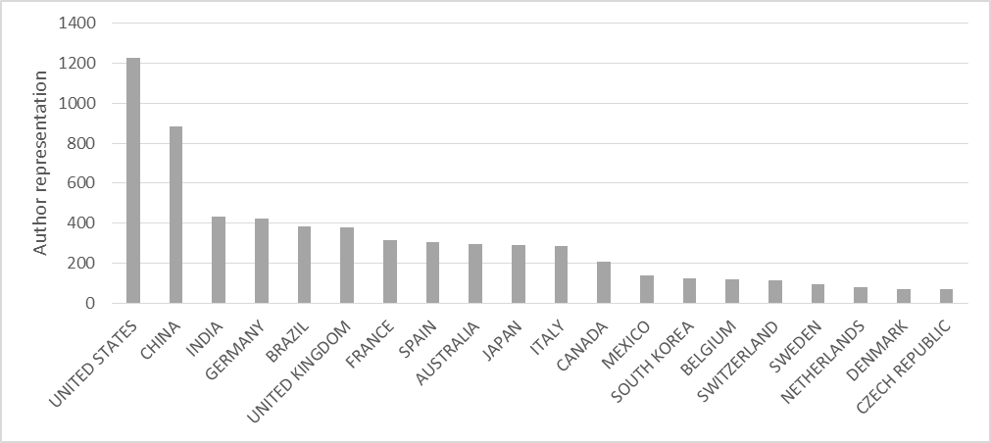

This figure shows the 20 most research productive countries. We used author representation as a proxy for research productivity, where each country gets a count once for each author representation in the corpus. Think of it like species richness for authors.

**Variables in the Scopus dataset (31 March 2019):**

Diversity indices:

From the UN:

DI

AI

# Plant (species) total

# Plant (species) endemic

GBIF species richness

AvTD

GBIF / area

# endemic / GBIF

Publication information:

Author representation

All mismatch (no authors Country of Origin [CoO] = plant species CoO)

Mismatch (any author CoO ≠ species CoO; counts per author CoO)

Single author mismatch (this one is for single author papers)

First author mismatch

Last author mismatch

Middle author mismatch

Economics and demographics

Human population

Agriculture (% of land use)

Human development index (World Bank; only relevant to Africa)

Land area

Educational attainment

GINI index (World Bank; metric of income inequality)

Poverty headcount ratio at national poverty lines (% of population)

GDP per capita, PPP (constant 2011 international $)

Children in employment, total (% of children ages 7-14)

Political Stability and Absence of Violence/Terrorism: Estimate

Political Stability/No Violence (estimate)

Research/biology-related economics and demographics

Research and development expenditure (% of GDP)

Researchers in R&D (per million people)

Total outbound internationally mobile tertiary students studying abroad, all countries, both sexes

Expenditure on tertiary as % of total government expenditure (%)

Graduates from tertiary education, both sexes (number)

Scientific and technical journal articles

Terrestrial and marine protected area (% of total territorial area)

Animal species, threatened

Mammal species, threatened

Plant species (higher), threatened

Fish species, threatened

Bird species, threatened

Exactly as written in R:

[1] "year"

[2] "country"

[3] "development"

[4] "region"

[5] "subregion"

[6] "cc"

[7] "gbifDiversity"

[8] "Population, total"

[9] "Agricultural land (% of land area)"

[10] "Human development index (HDI)"

[11] "Land area (sq. km)"

[12] "lat"

[13] "long"

[14] "DI"

[15] "AI"

[16] "PlantsTotal"

[17] "PlantsEndemic"

[18] "authorRepresentation"

[19] "Educational attainment, at least Bachelor's or equivalent, population 25+, total (%) (cumulative)"

[20] "GINI index (World Bank estimate)"

[21] "allMismatch"

[22] "mismatch"

[23] "firstAuthorMismatch"

[24] "lastAuthorMismatch"

[25] "singleAuthorMismatch"

[26] "Poverty headcount ratio at national poverty lines (% of population)"

[27] "middleAuthorMismatch"

[28] "GDP per capita, PPP (constant 2011 international $)"

[29] "Terrestrial and marine protected areas (% of total territorial area)"

[30] "Children in employment, total (% of children ages 7-14)"

[31] "Political Stability and Absence of Violence/Terrorism: Estimate"

[32] "Political Stability/No Violence (estimate)"

[33] "Research and development expenditure (% of GDP)"

[34] "Researchers in R&D (per million people)"

[35] "Total outbound internationally mobile tertiary students studying abroad, all countries, both sexes (number)"

[36] "Expenditure on tertiary as % of total government expenditure (%)"

[37] "Graduates from tertiary education, both sexes (number)"

[38] "Scientific and technical journal articles"

[39] "Animal species, threatened"

[40] "Mammal species, threatened"

[41] "Plant species (higher), threatened"

[42] "Fish species, threatened"

[43] "Bird species, threatened"

Economic stuff:

[1] "year"

[2] "country"

[3] "development"

[4] "region"

[5] "subregion"

[6] "cc"

[7] "gbifDiversity"

[8] "Population, total"

[9] "Agricultural land (% of land area)"

[10] "Human development index (HDI)"

[19] "Educational attainment, at least Bachelor's or equivalent, population 25+, total (%) (cumulative)"

[20] "GINI index (World Bank estimate)"

[26] "Poverty headcount ratio at national poverty lines (% of population)"

[28] "GDP per capita, PPP (constant 2011 international $)"

[30] "Children in employment, total (% of children ages 7-14)"

[31] "Political Stability and Absence of Violence/Terrorism: Estimate"

[32] "Political Stability/No Violence (estimate)"

[33] "Research and development expenditure (% of GDP)"

[34] "Researchers in R&D (per million people)"

[35] "Total outbound internationally mobile tertiary students studying abroad, all countries, both sexes (number)"

[36] "Expenditure on tertiary as % of total government expenditure (%)"

[37] "Graduates from tertiary education, both sexes (number)"

[38] "Scientific and technical journal articles"

Author stuff:

[18] "authorRepresentation"

[21] "allMismatch"

[22] "mismatch"

[23] "firstAuthorMismatch"

[24] "lastAuthorMismatch"

[25] "singleAuthorMismatch"

[27] "middleAuthorMismatch"

Diversity stuff:

[7] "gbifDiversity"

[11] "Land area (sq. km)"

[14] "DI"

[15] "AI"

[29] "Terrestrial and marine protected areas (% of total territorial area)"

[39] "Animal species, threatened"

[40] "Mammal species, threatened"

[41] "Plant species (higher), threatened"

[42] "Fish species, threatened"

[43] "Bird species, threatened"